|  |  |
| --- | --- |
| **GIT Repo** | <https://github.com/Prashanth6782/CICD_Dummies_HV> |
| **Python** | https://github.com/Prashanth6782/CICD_Dummies_HV/tree/main/python_scripts |
| **Shell Scripts** | https://github.com/Prashanth6782/CICD_Dummies_HV/tree/main/shell_script |
| **Other Temporary files** | https://github.com/Prashanth6782/CICD_Dummies_HV/blob/main/otherfiles/check_commits.log |
| **Startup script** | I have shown it as part of the below word document |

* **Task 1:** Set Up a Simple HTML Project
  + - Create a simple HTML project and push it to a GitHub repository.
* **Task 2:** Set Up an AWS EC2/Local Linux Instance with Nginx
* **Task 3:** Write a Python Script to Check for New Commits
  + - Create a Python script to check for new commits using the GitHub API.
* **Task 4:** Write a Bash Script to Deploy the Code
  + - Create a bash script to clone the latest code and restart Nginx.
* **Task 5:** Set Up a Cron Job to Run the Python Script
  + - Create a cron job to run the Python script at regular intervals.
* **Task 6:** Test the Setup
  + - Make a new commit to the GitHub repository and check that the changes are automatically deployed.

# TASK1

**Created a new repository in GITHUB**

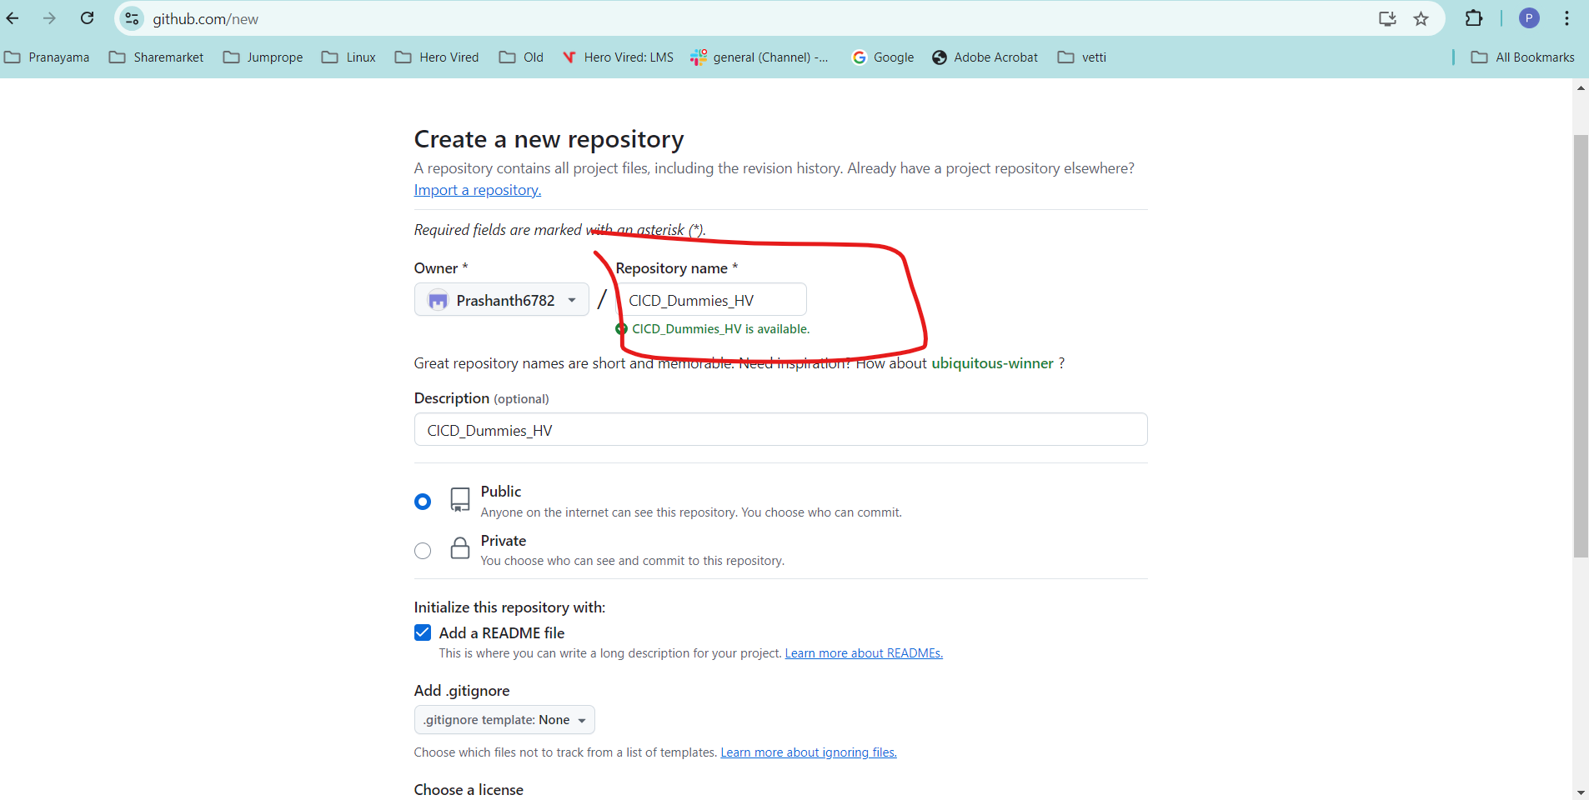

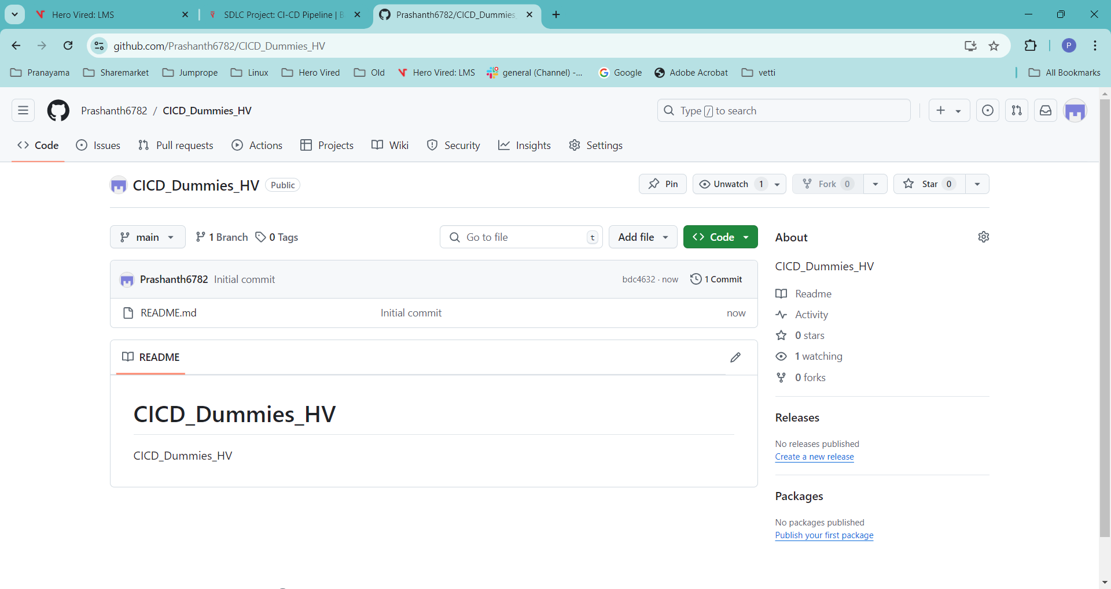

**Clone into Windows Path Initially to create the HTMl**

|  |
| --- |
|  |

**Created a Index.html**

|  |
| --- |
|  |

**Commit and push into GITHUB**

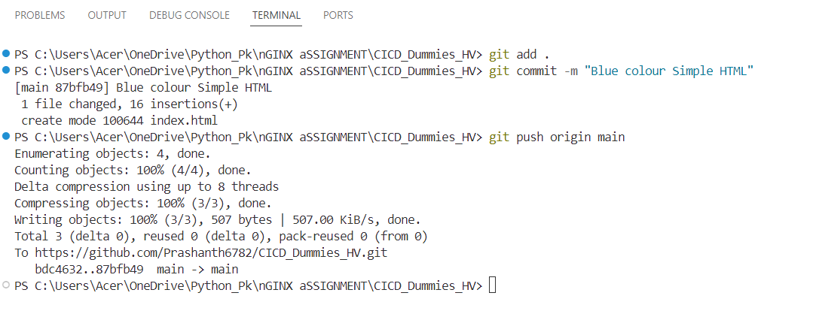

**Can see it in GITHUB now**

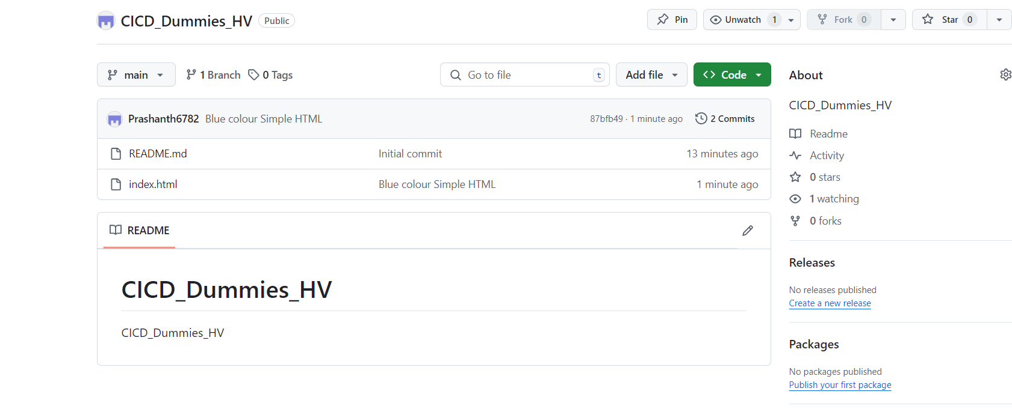

Task 2**:** Set Up an AWS EC2/Local Linux Instance with Nginx deploying the app1

**Create an Ec2 Instance running and hosting our simple html in app1**

**Im running all instructions as part of the start up script for ease and the startup script is shown below**

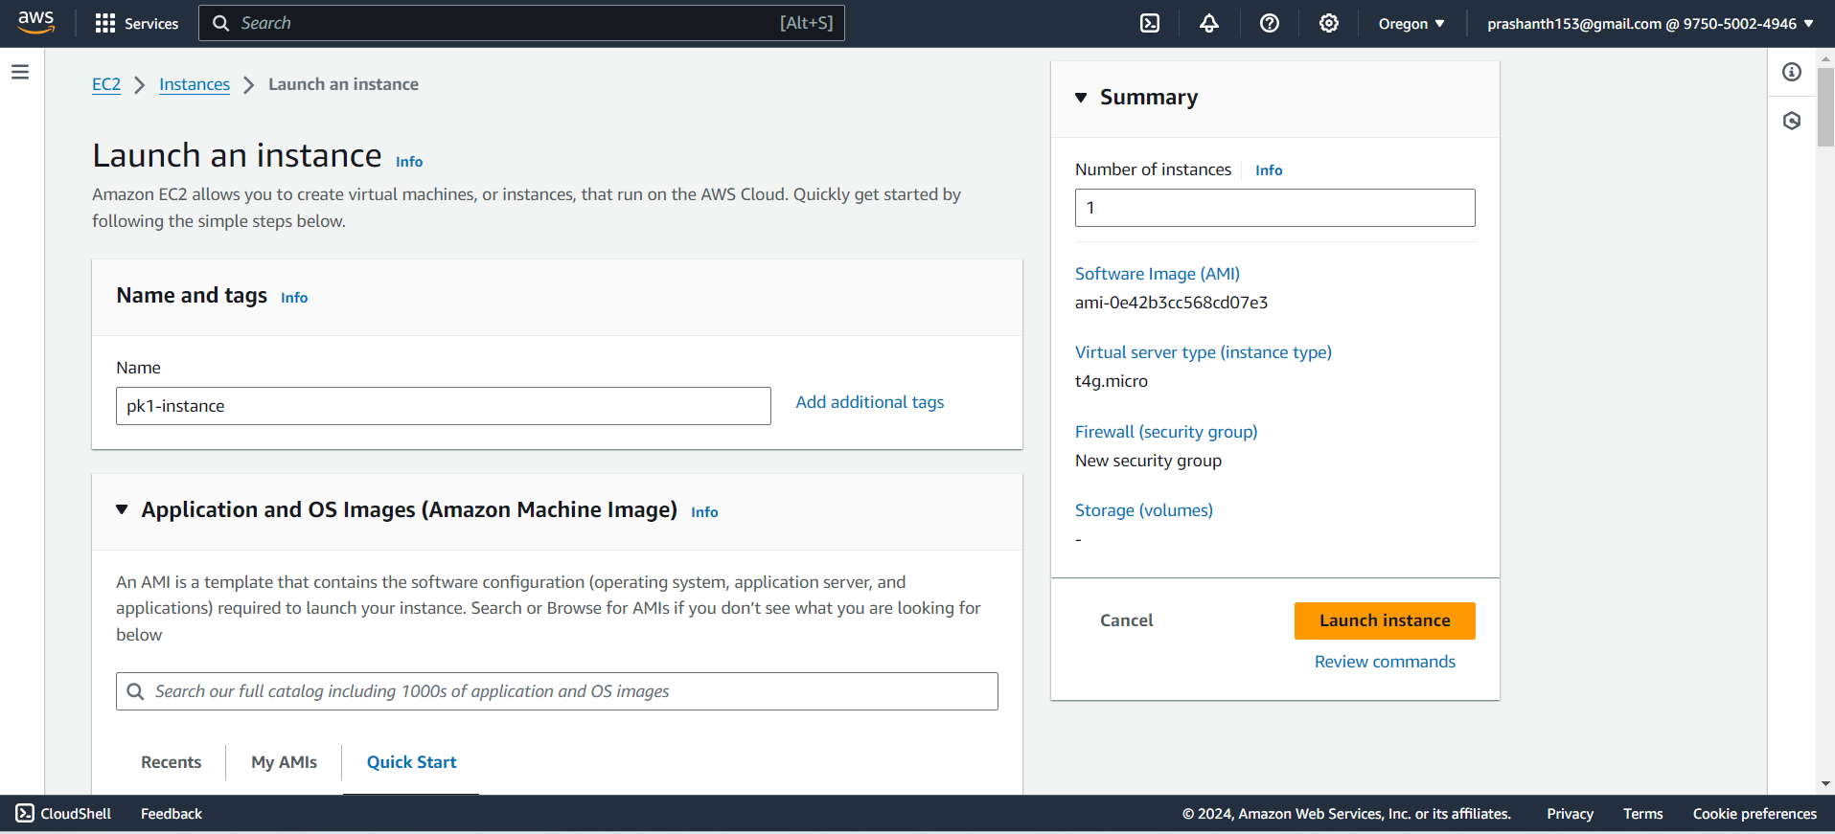

**Startup script**

|  |
| --- |
| #!/bin/bash  # Log file to store the script's output  LOGFILE="/var/log/startup_script.log"  # Function to log output with timestamp  log() {  echo "$(date '+%Y-%m-%d %H:%M:%S') - $1" | tee -a "$LOGFILE"  }  log "Starting startup script"  # Update the package list and install necessary packages  log "Updating package list and installing necessary packages"  apt-get update >> "$LOGFILE" 2>&1  # Install sudo if not installed  log "Installing sudo"  apt-get -y install sudo >> "$LOGFILE" 2>&1  # Install Nginx to serve the HTML  log "Installing Nginx"  sudo apt-get -y install nginx >> "$LOGFILE" 2>&1  # Install git if not installed  log "Installing git"  sudo apt-get -y install git >> "$LOGFILE" 2>&1  # Clone the GitHub repository to /home/ubuntu  log "Cloning the GitHub repository"  REPO_URL="https://github.com/Prashanth6782/CICD_Dummies_HV.git"  CLONE_DIR="/home/ubuntu/repo"  if sudo git clone "$REPO_URL" "$CLONE_DIR" >> "$LOGFILE" 2>&1; then  log "Repository cloned successfully"  else  log "Error cloning the repository"  exit 1  fi  # Create the /var/www/html/app1 directory if it doesn't exist  log "Creating /var/www/html/app1 directory"  sudo mkdir -p /var/www/html/app1 >> "$LOGFILE" 2>&1  # Give necessary permissions to the /var/www/html/app1 directory  log "Setting permissions for /var/www/html/app1"  sudo chown -R www-data:www-data /var/www/html/app1 >> "$LOGFILE" 2>&1  sudo chmod -R 755 /var/www/html/app1 >> "$LOGFILE" 2>&1  # Copy the index.html file from the cloned repository  log "Copying index.html from the repository"  INDEX_HTML_SRC="/home/ubuntu/repo/index.html"  INDEX_HTML_DEST="/var/www/html/app1/index.html"  if [ -f "$INDEX_HTML_SRC" ]; then  sudo cp "$INDEX_HTML_SRC" "$INDEX_HTML_DEST" >> "$LOGFILE" 2>&1  log "index.html copied successfully"  else  log "Error: Source index.html file not found at $INDEX_HTML_SRC"  exit 1  fi  # Ensure Nginx is running and enable it to start on boot  log "Starting and enabling Nginx"  sudo systemctl start nginx >> "$LOGFILE" 2>&1  sudo systemctl enable nginx >> "$LOGFILE" 2>&1  # Restart Nginx to make sure changes are applied  log "Restarting Nginx"  sudo systemctl restart nginx >> "$LOGFILE" 2>&1  # Open port 80 in the firewall  log "Allowing Nginx through the firewall"  sudo ufw allow 'Nginx Full' >> "$LOGFILE" 2>&1  log "Startup script completed successfully" |

**HTML is opening now successfully with NGINX**

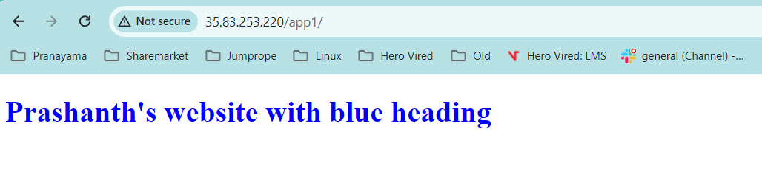

**Cronjob to run every minute to check for commits**

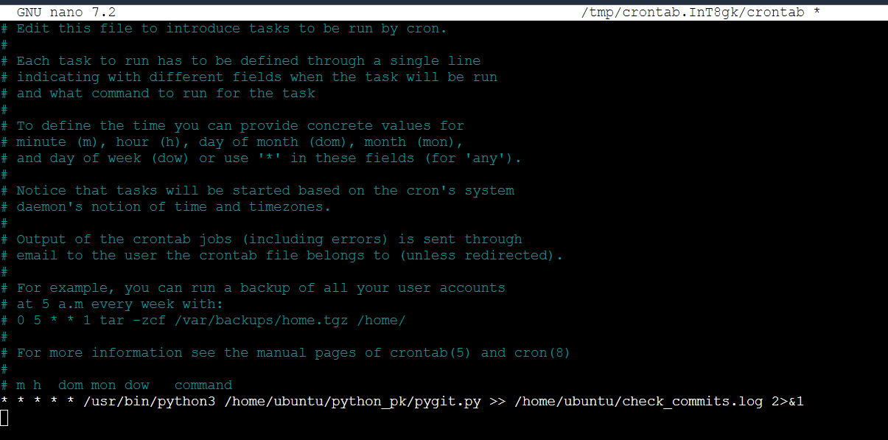

**Getting the following dependencies error when the cron is executed**

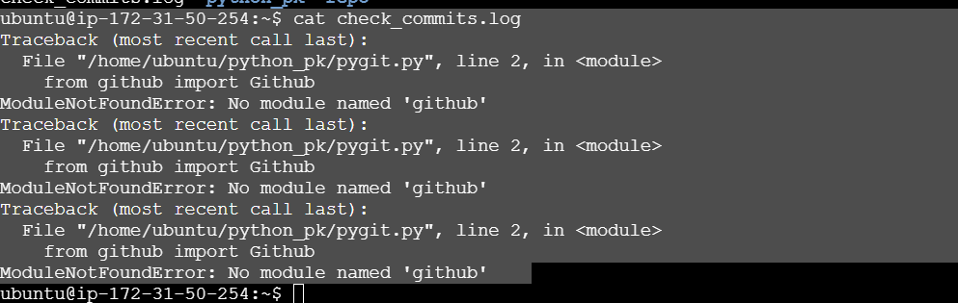

**Installing all the gith dependencies**

**Initial commit is stored in the last_commit file**

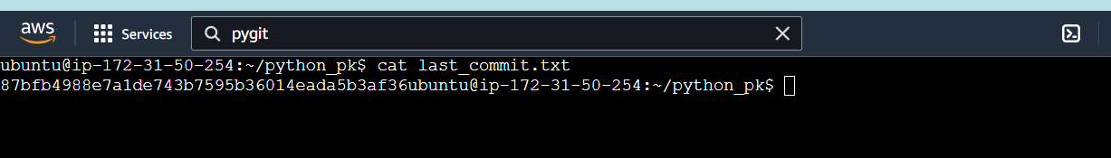

**Matches with commit found in github**

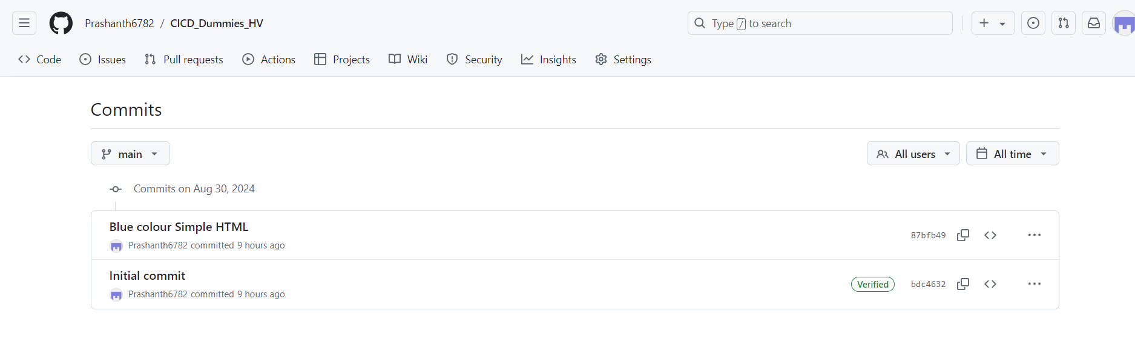

**Changing the html and pushing the RED colour code to GITHUB which should be picked up automatically now by the cronjob**

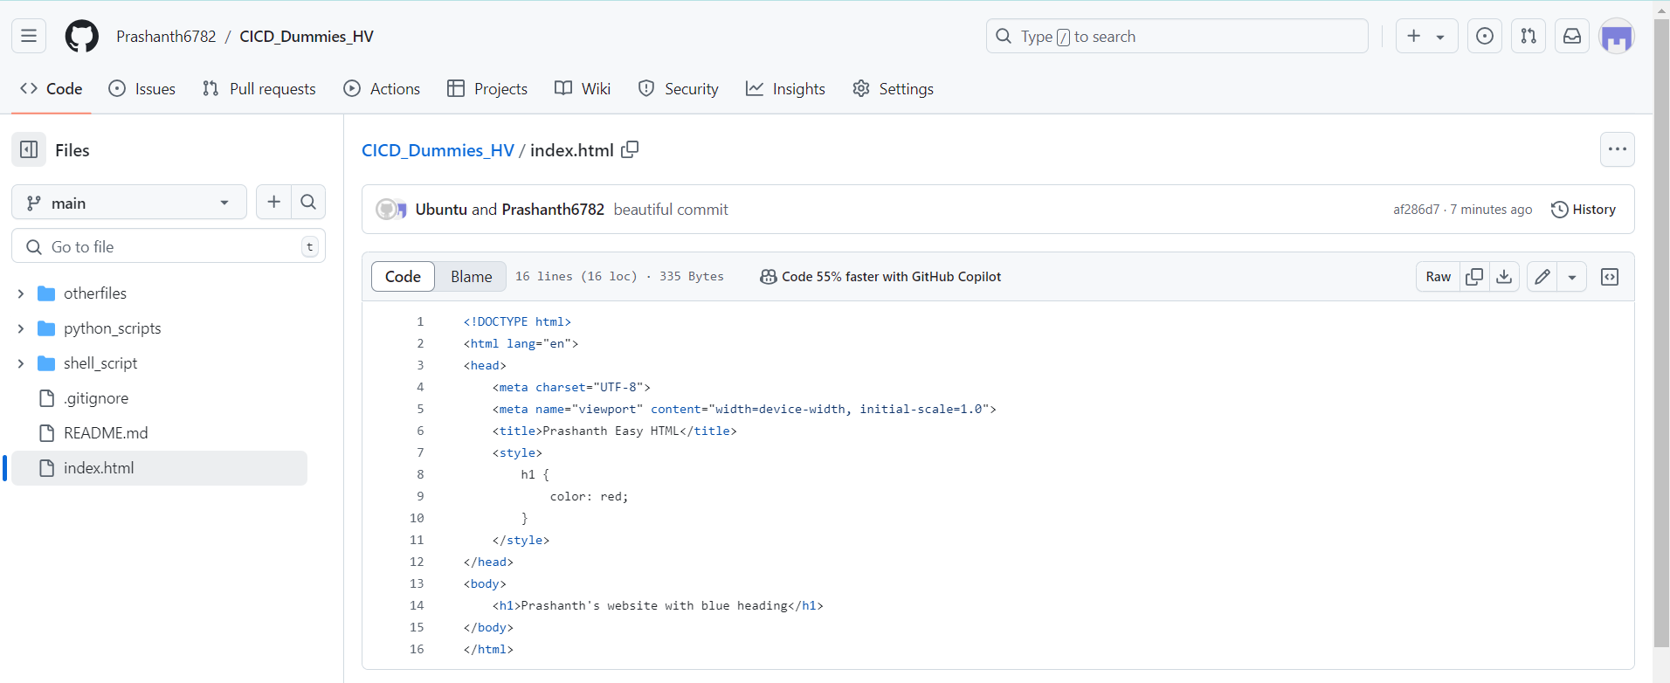

**Finally colour is changed to red automatically once the shell script is executed**

